Haplotypes and Informative SNP Selection Algorithms: Don’t Block Out Information
Vineet Bafna, Bjarni V. Halldorsson, Russell Schwaartz, Andrew G. Clark and Sorin Istrail
RECOMB ’03 (The Seventh Annual International Conference on Research in Computational Molecular Biology), pp. 19-27
Abstract
It is widely hoped that variation in the human genome will provide a means of predicting risk of a variety of complex, chronic diseases. A major stumbling block to the successful identification of association between human DNA polymorphisms (SNPs) and variability in risk of complex diseases is the enormous number of SNPs in the human genome. The large number of SNPs results in unacceptably high costs for exhaustive genotyping, and so there is a broad effort to determine ways to select SNPs so as to maximize the informativeness of a subset.
In this paper we contrast two methods for reducing the complexity of SNP variation: haplotype tagging, i.e. typing a subset of SNPs to identify segments of the genome that appear to be nearly unrecombined (haplotype blocks), and a new block-free model that we develop in this report.
We present a statistic for comparing haplotype blocks and show that while the concept of haplotype blocks is reasonably robust there is substantial variability among block partitions. We develop a measure for selecting an informative subset of SNPs in a block free model. We show that the general version of this problem is NP-hard and give efficient algorithms for two important special cases of this problem.
- Evaluating Haplotype Blocks
There are many computational approaches to predicting representing block boundaries:
- recombination-based: (Minimun Test Cover)
No block should exhibit all four possible gametes
- diversity-based: (Minimun Block)
A region is a block if at least 80% of the sequences occur in more than one chromosomes
- LD-based:
A region is defined to be a block if the D’ value of every pair of SNPs within the block shows significant LD given the individual SNP allele frequencies
▲B₁, B₂ : the number of boundaries of two partitions
- m : the number oof boundaries shared by the partitions
- S : the total number of SNPs
The probability that they share exactly m boundaries can be calculated as follows:
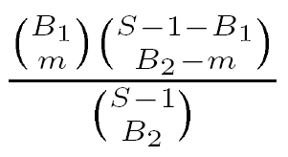
The P-value for the intersection of the two partitions being random can then be calculated as follows:
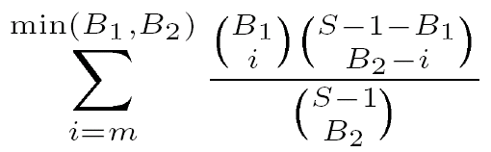
- Computational Results
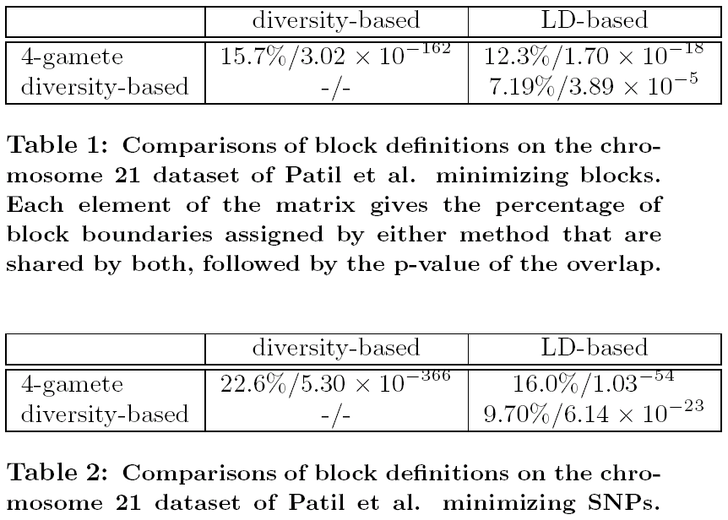
Minimum SNP solutions appear to have more in common with one another than minimum block solutions.
- Informativeness Measurement
A set S of m SNPs over a population of n haplotypes can be denoted by an nxm matrix Ms. For a SNP s and haplotypes i, j, let 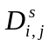 be the event that M[i,s]≠M[j,s]. Define the informativeness of SNP s w.r.t a SNP t as:
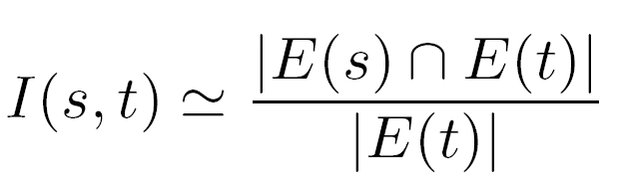
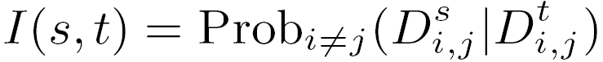
- SNP Neighborhood Selection
We would like to find a most informative subset of SNPs given that only SNPs that are a distance w apart can be used in the prediction:
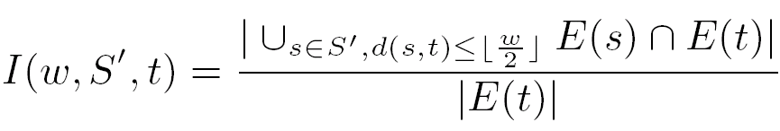
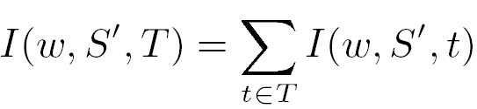
- Results
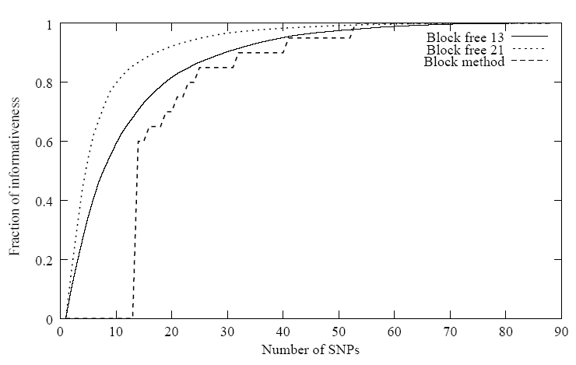

Date: Feb. 18, 2004
Created by: Chia-Ling Sun

B1 = 4 : b1 b2 b3 b4
B2 = 3 : b1’ b2’ b3’
S=10 : s₁ s₂ s₃ s₄ s₅ s₆ s₇ s₈ s₉ s₁₀
Probability of exactly 2 boundaries shared:

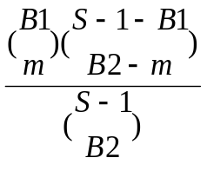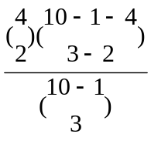

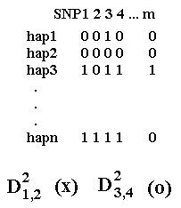
I(s,t)=1 implies complete predictability
I(s,t)=0 when there is no predictability
I(2,1)=Prob.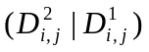
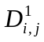, (i,j) = (1,3)(1,4)(2,3)(2,4)
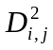 (i,j) = (1,4)(2,4)(3,4)
Prob.= 1/2 ≒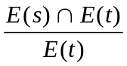
At SNP1:
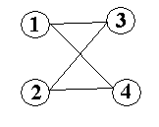
At SNP2:
